**LAB 14**

**Zirwah Khalil i220748**

**C-Net A**

**ACL**

**Lab Work 01**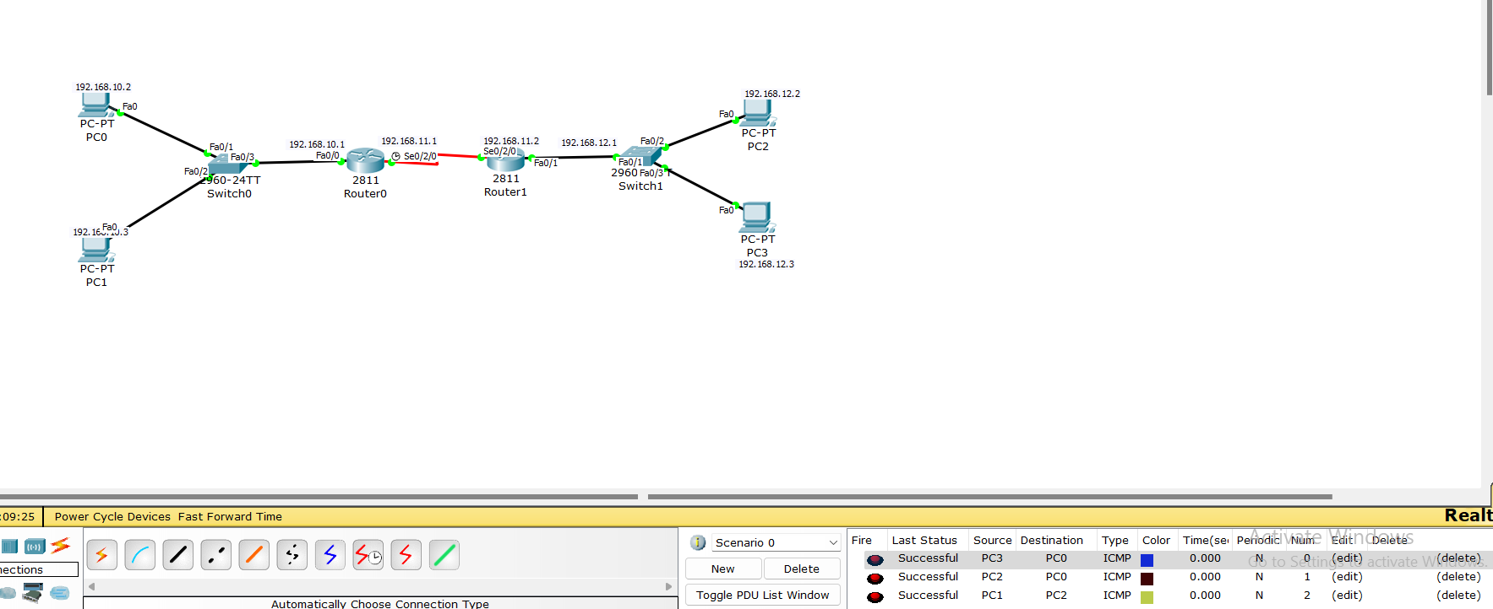

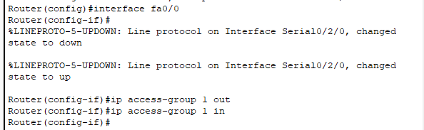

After:  


**Lab Task 01**

From Router 1

From Router 2

After ACL



